Android Studio Install:

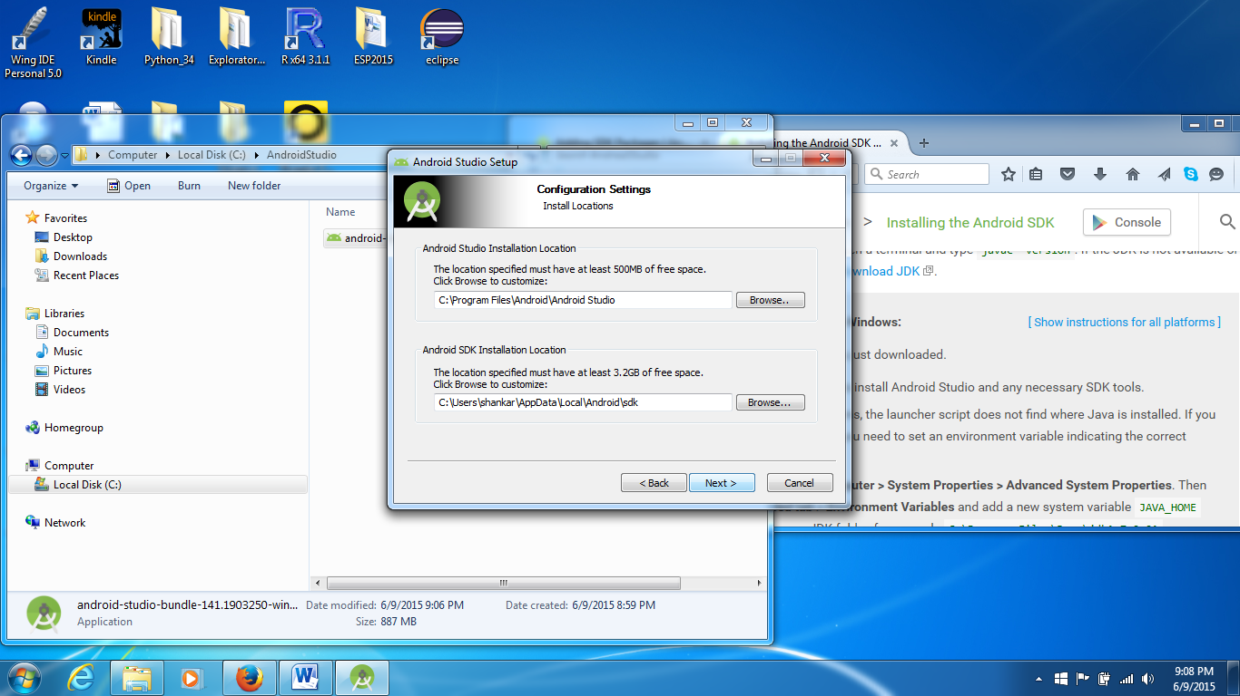

Failed to install Intel Acceleration (I think I have AMD)

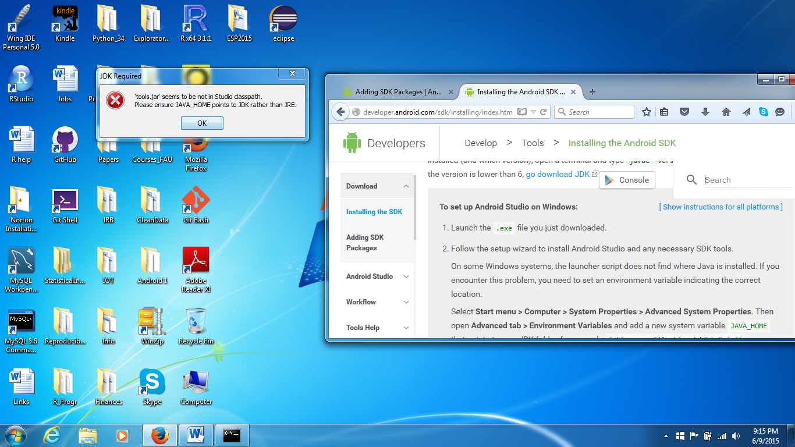

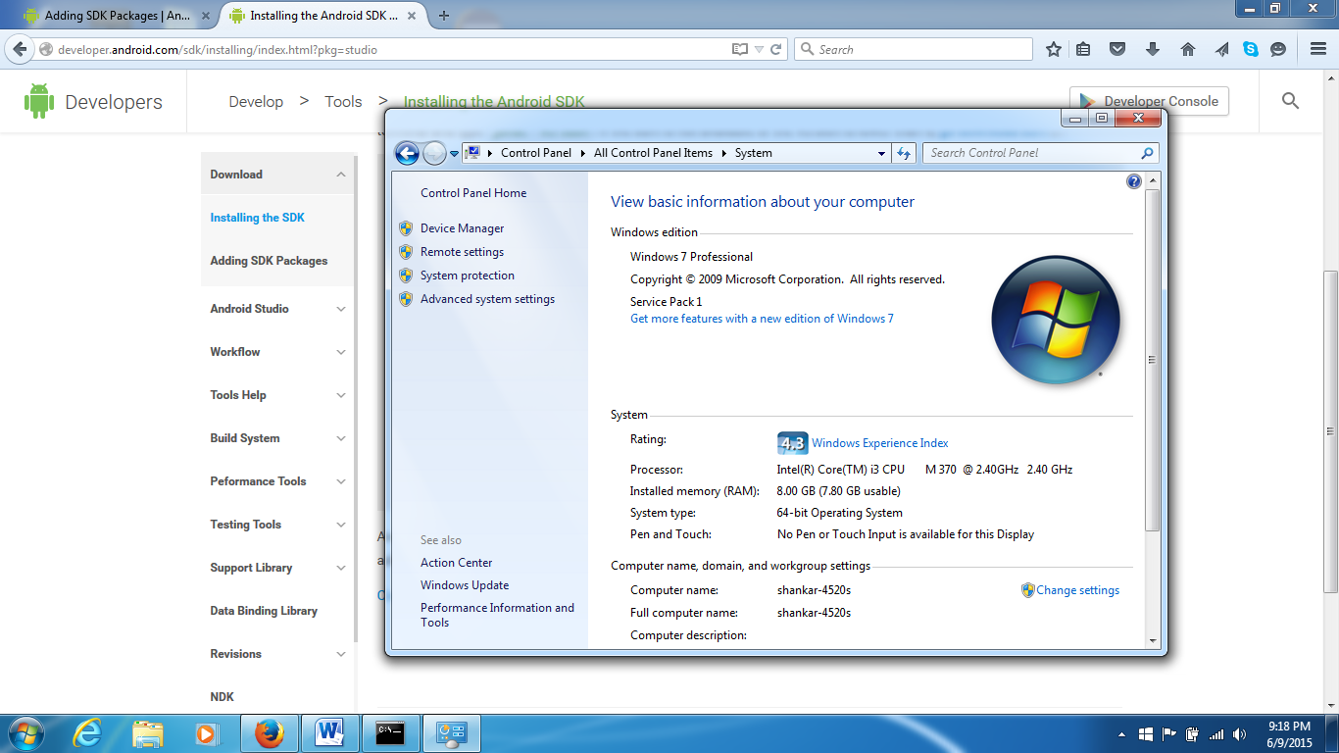

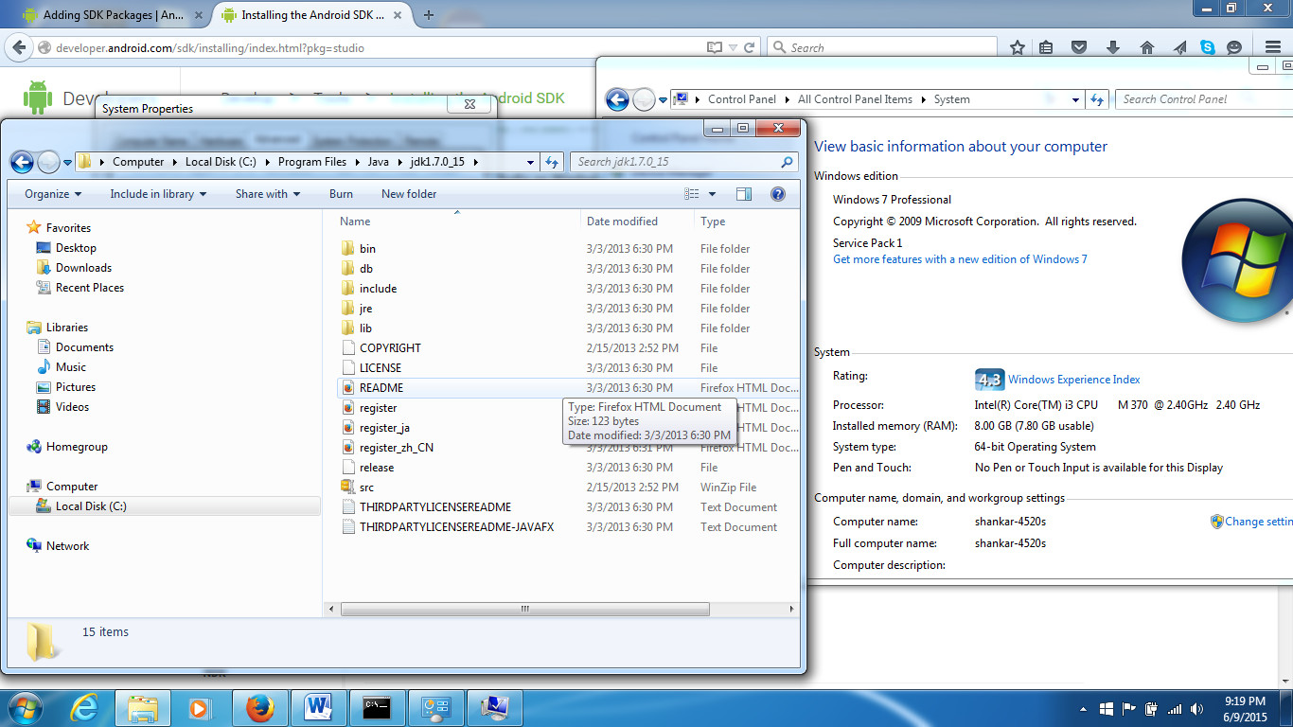

JDK path updated to: C:\Program Files\Java\jdk1.7.0_15

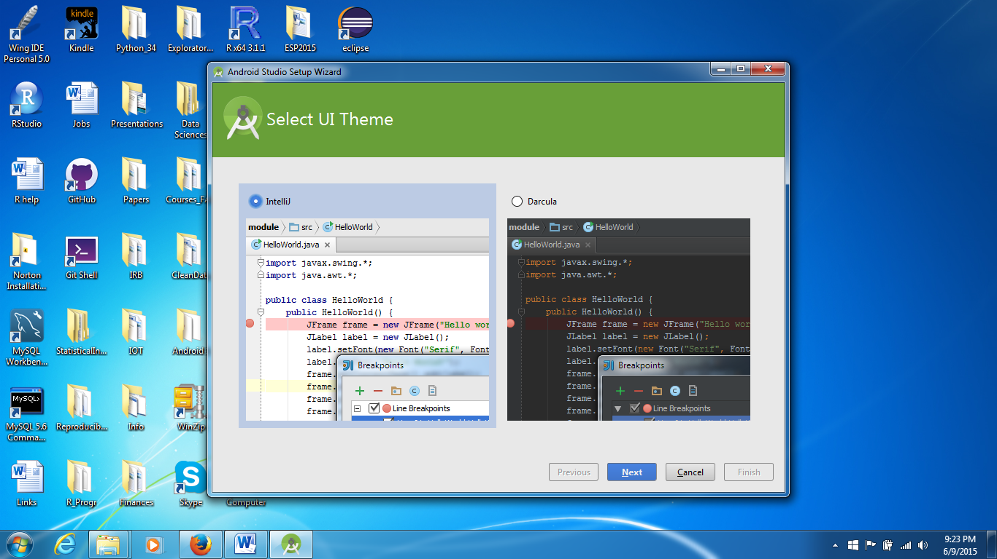

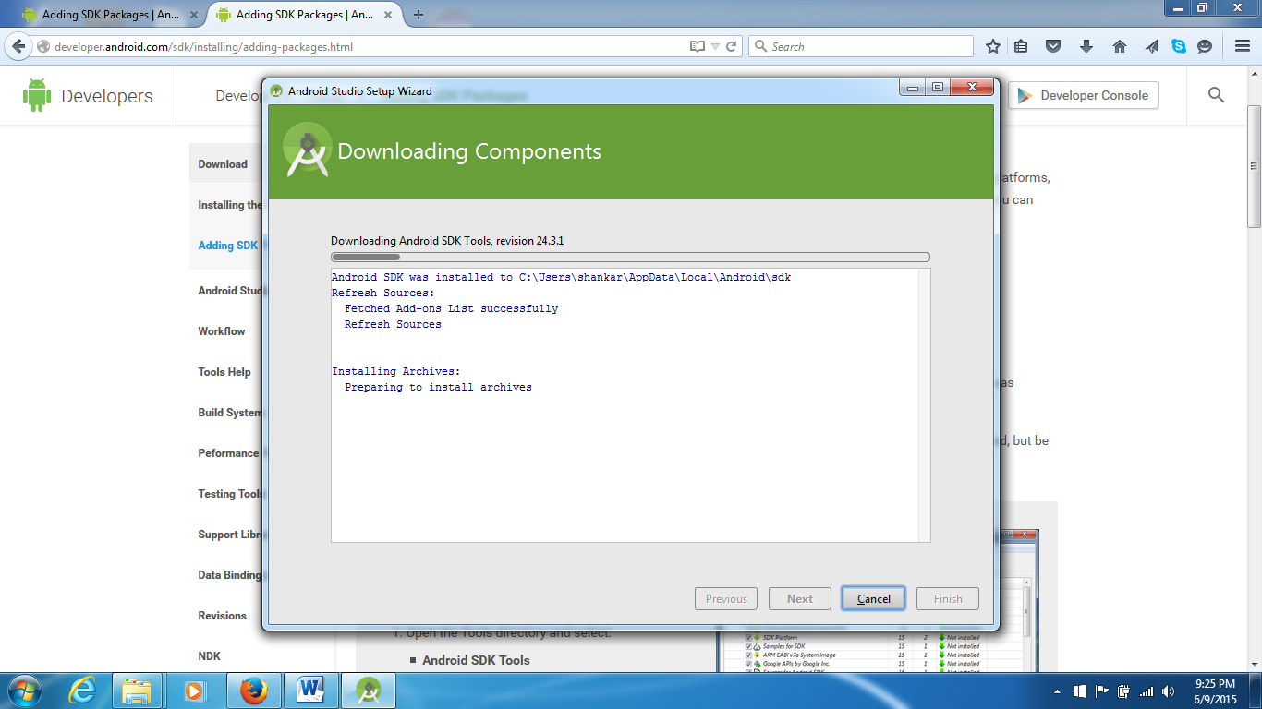

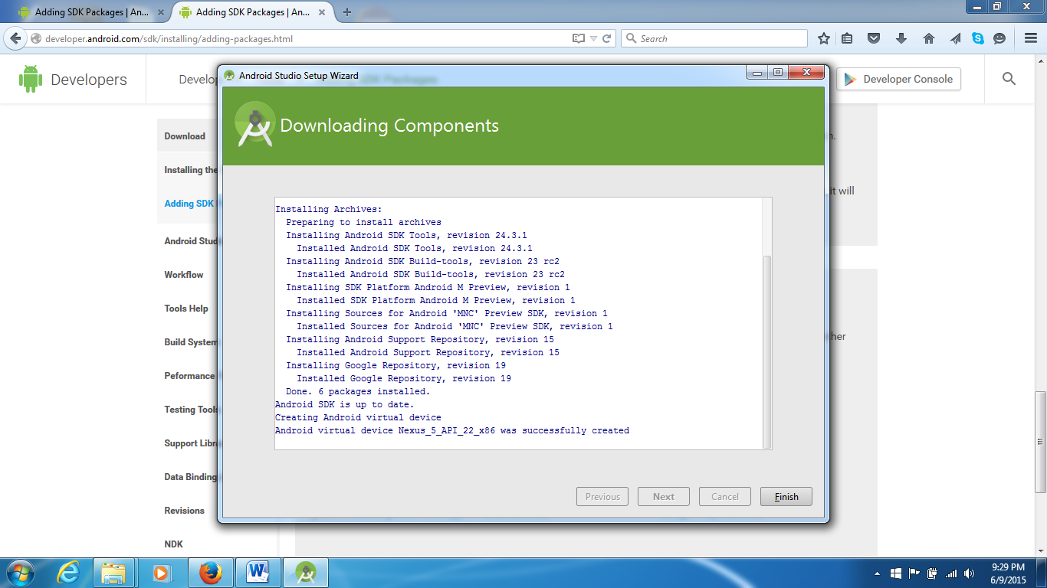

It was fast so far!

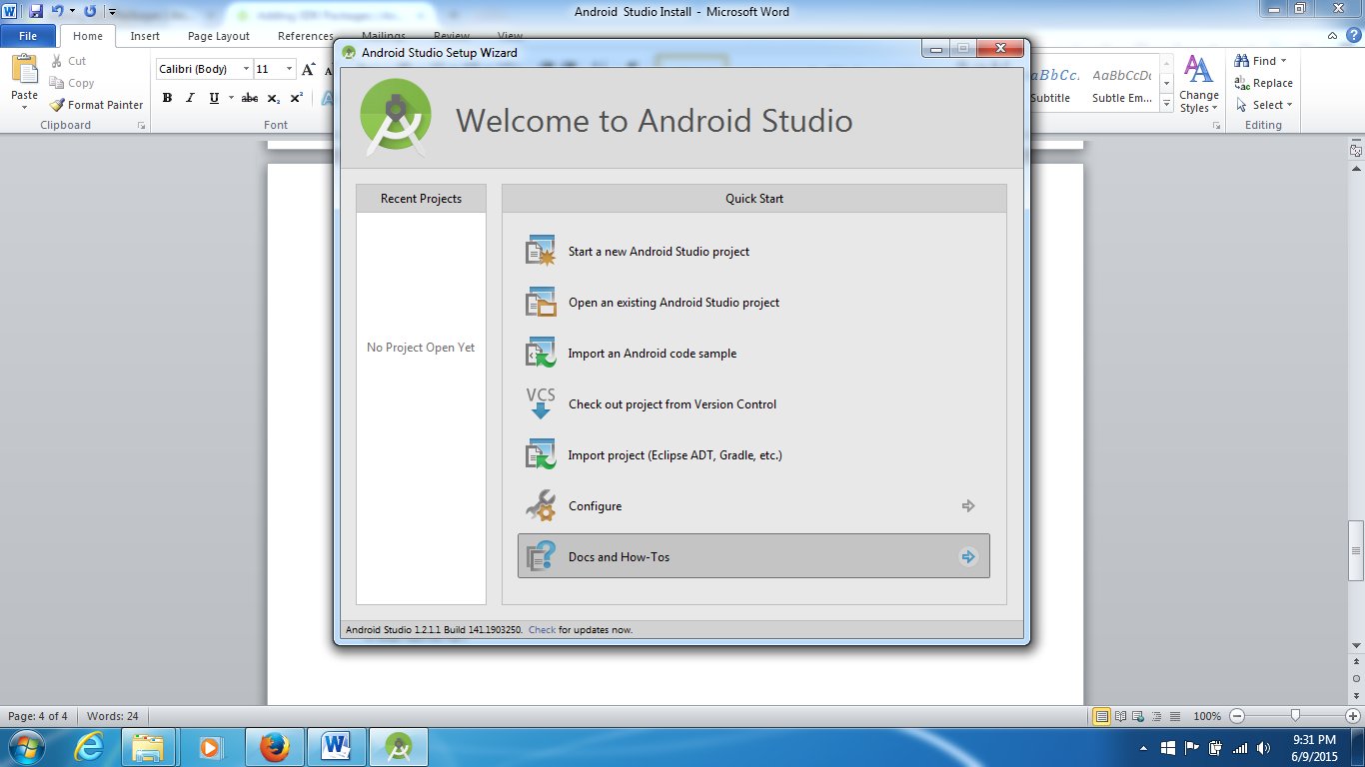

Choose Configure to add more of SDK. Ref: <http://developer.android.com/sdk/installing/adding-packages.html>

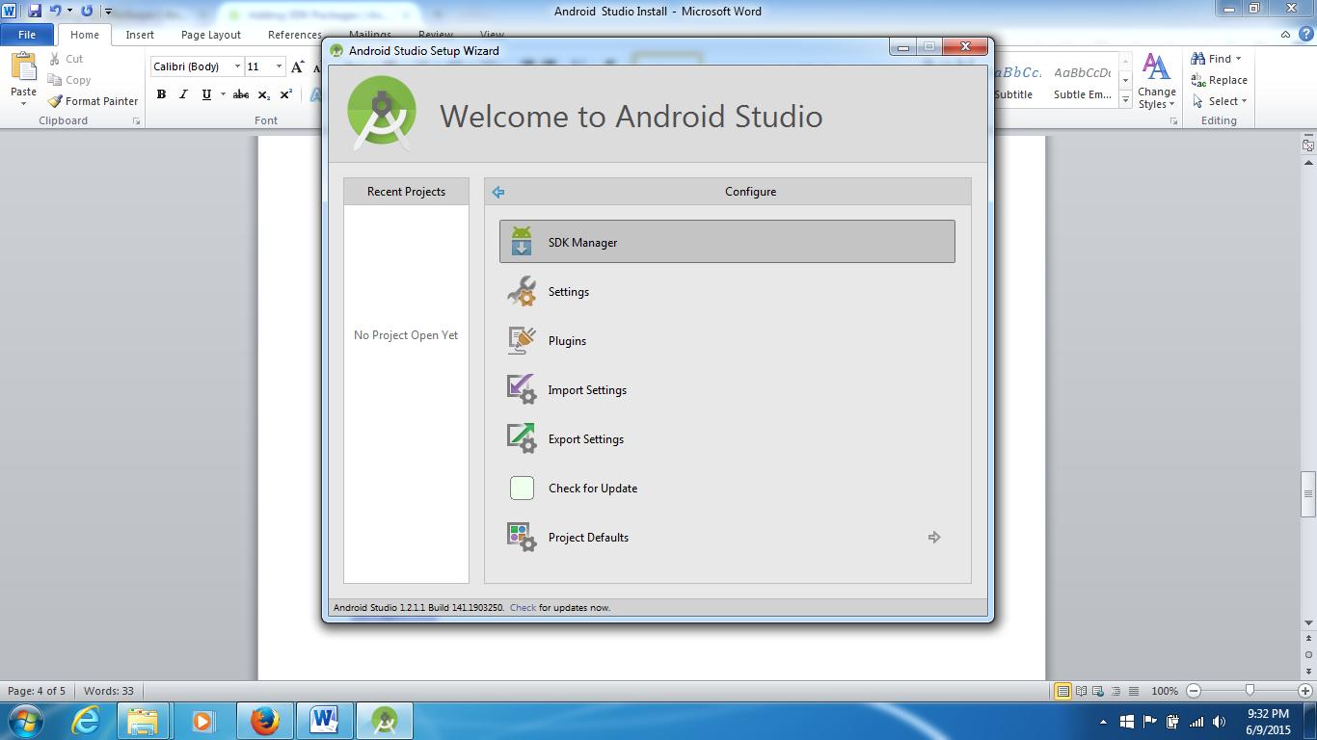

5.1 was loaded. I added 4.4, 4.3, 2.3.3, and others listed at the Android site: <http://developer.android.com/sdk/installing/adding-packages.html>

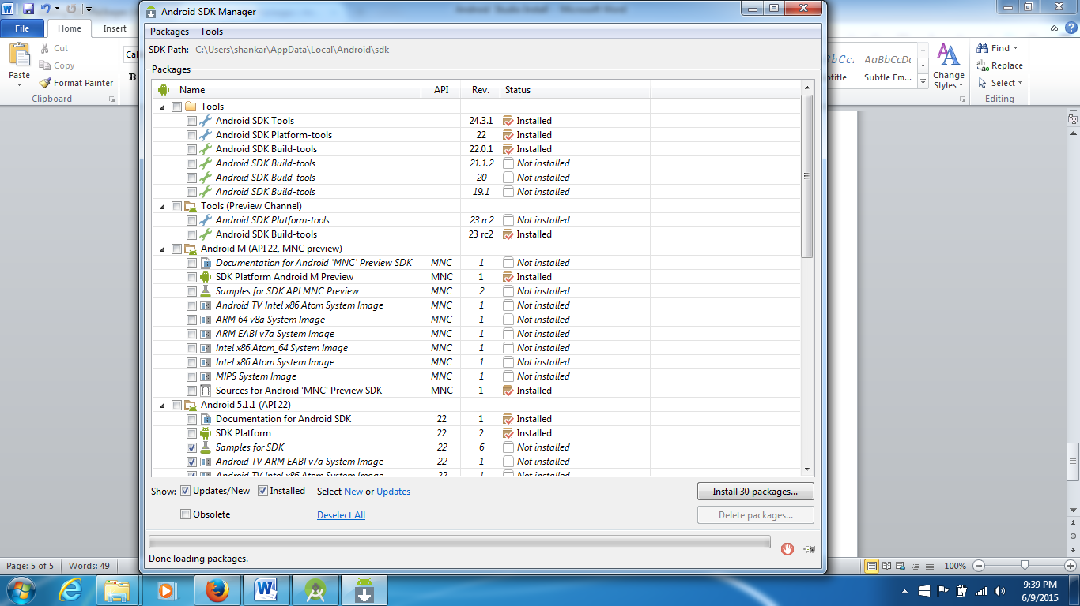

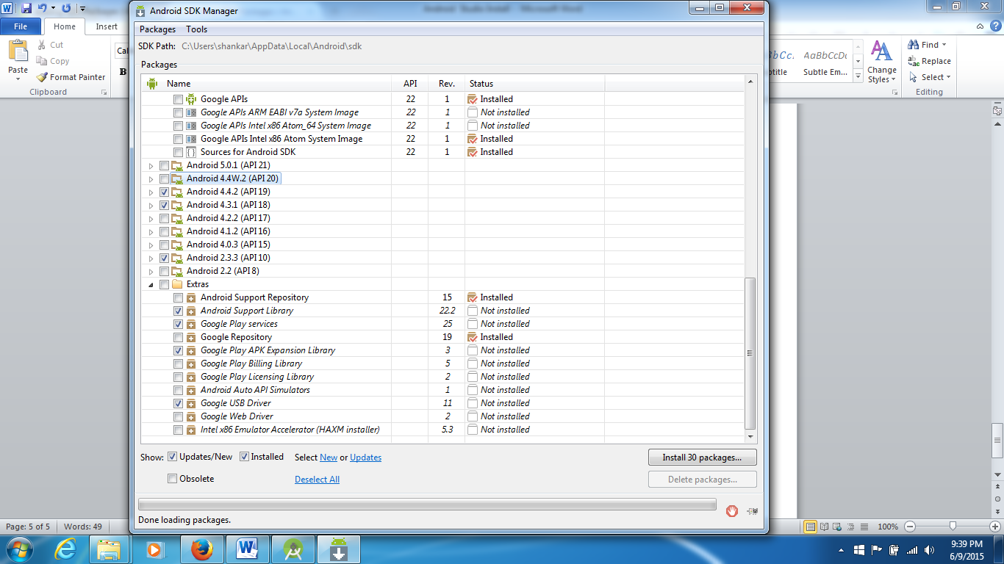

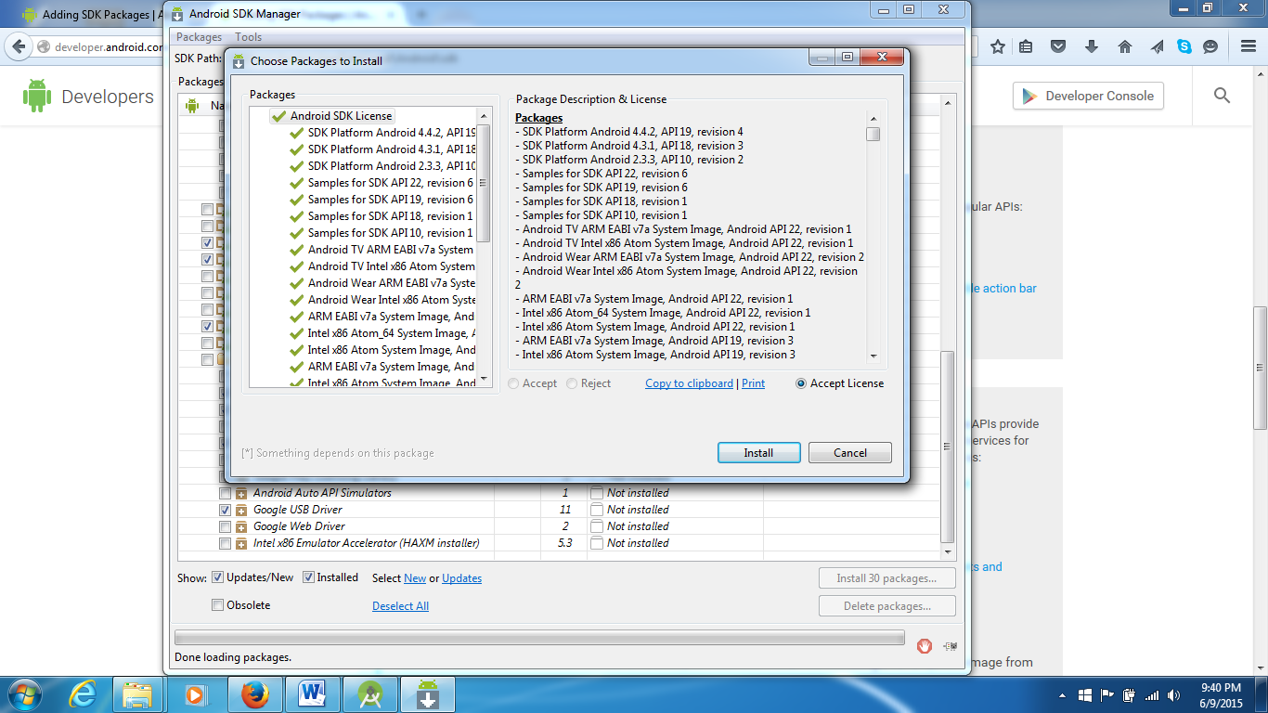

Took 30 minutes (on WiFi)

Reason for this big download: I will be using the new version soon; also, there may be some dependencies that may not allow proper functioning. So, it was better to just spend a little extra time and install most of the newest version and tools.

Added a few more packages:

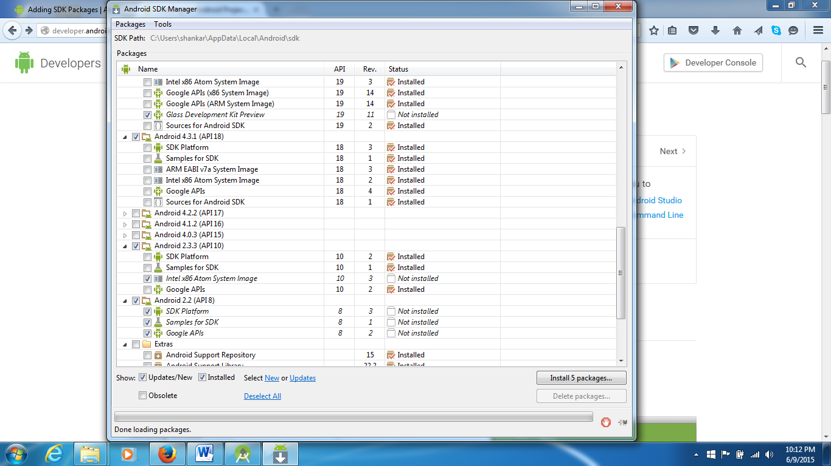

Done in 1 minute.

Get Started in developing an App:

Pages at android.com: Create an app – see: <http://developer.android.com/training/basics/firstapp/creating-project.html> -- ignore the command line parts

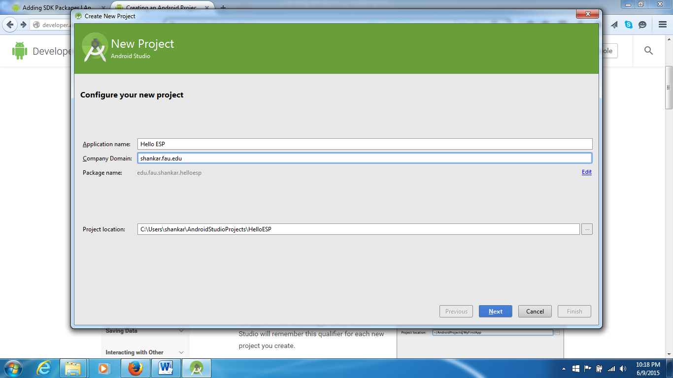

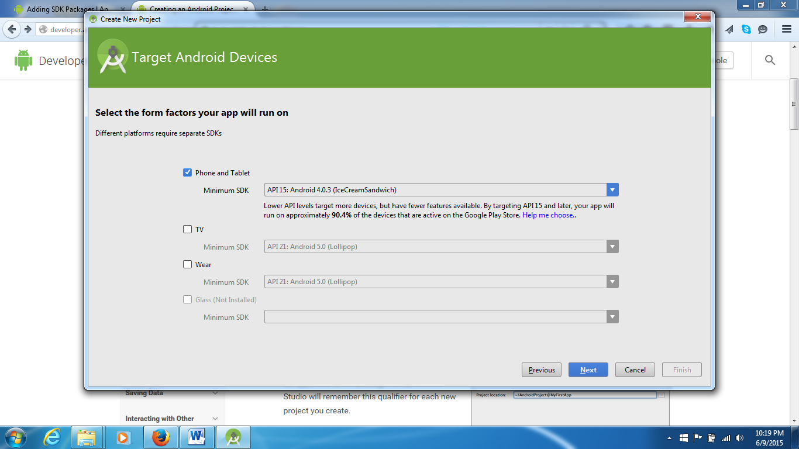

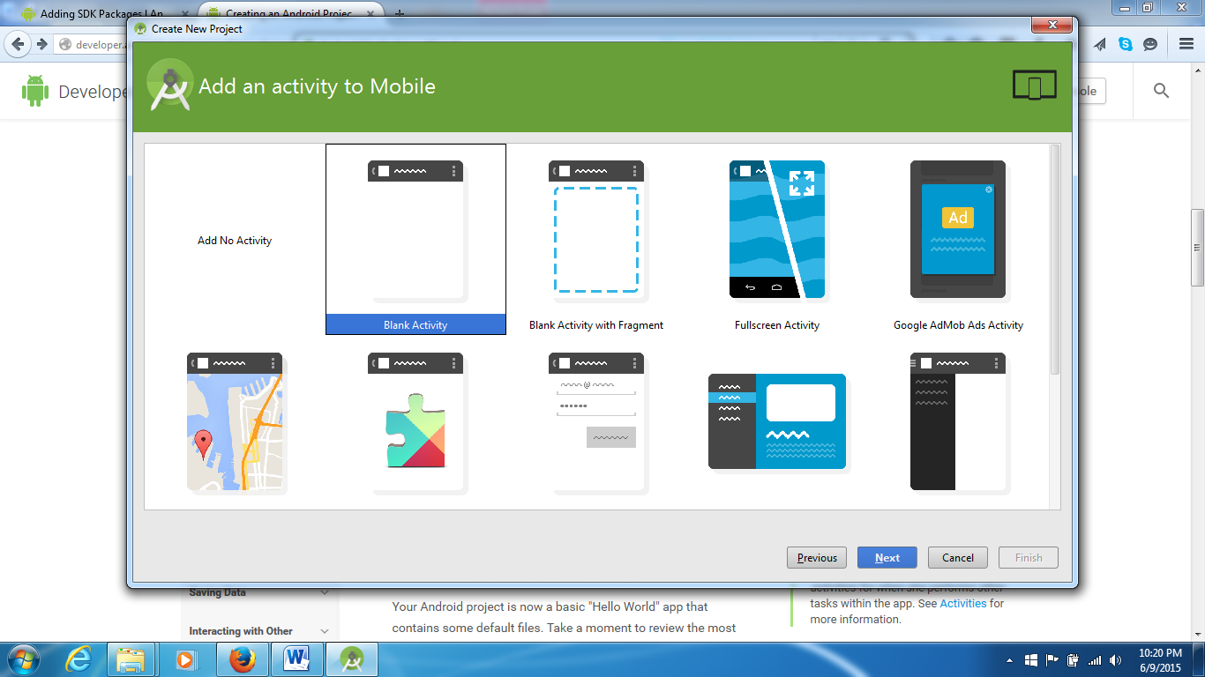

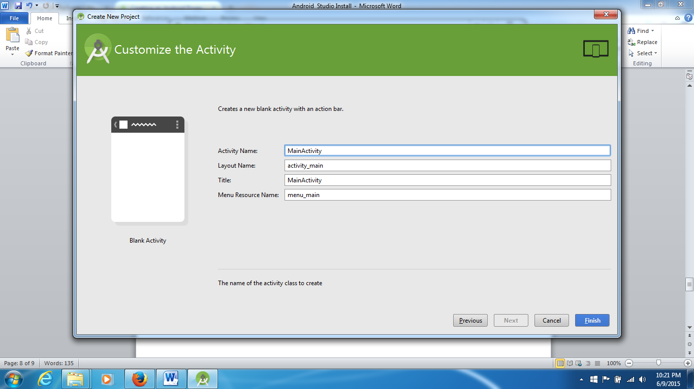

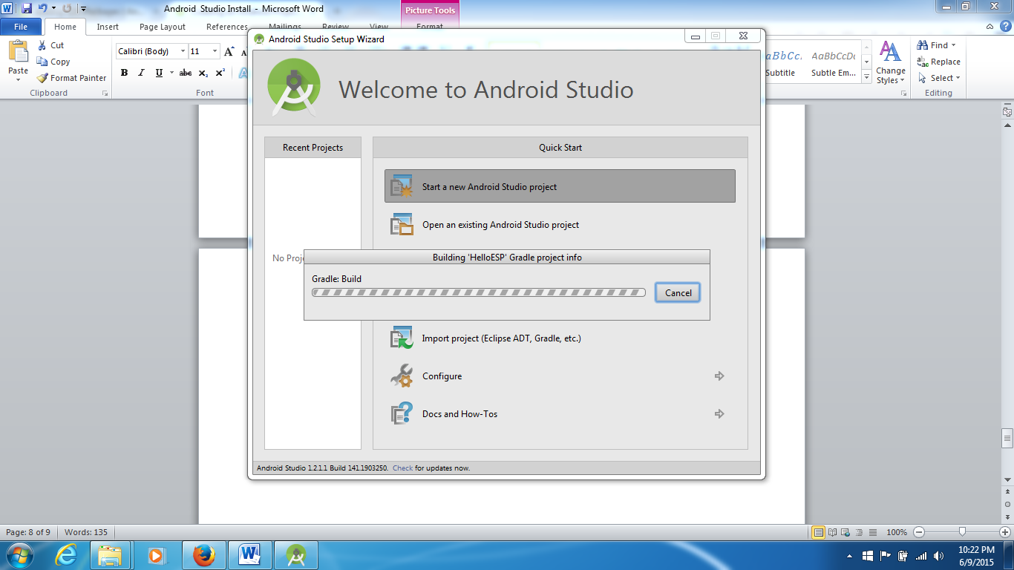

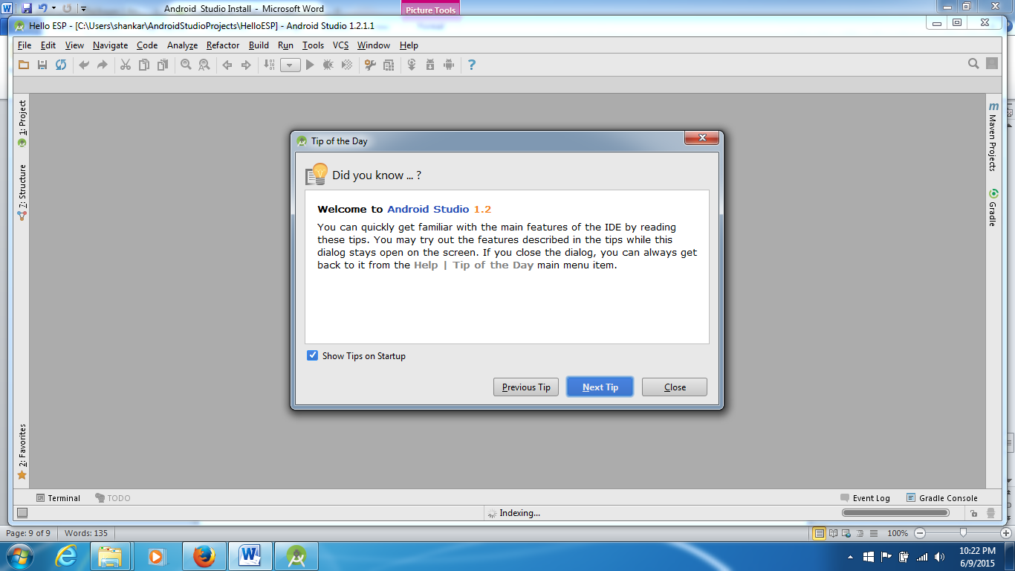

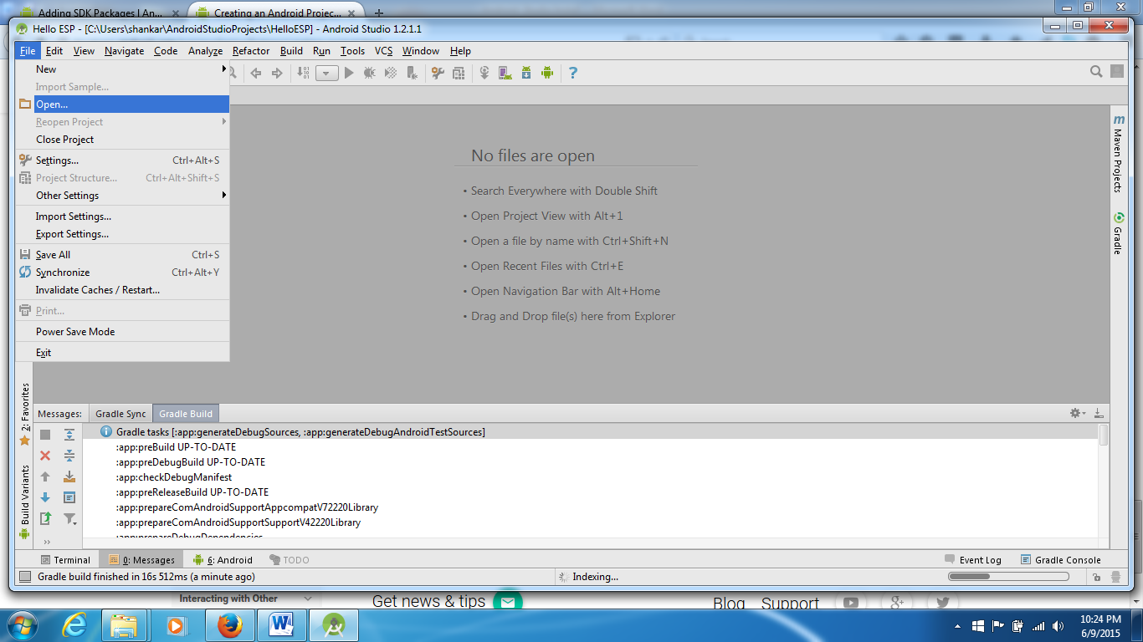

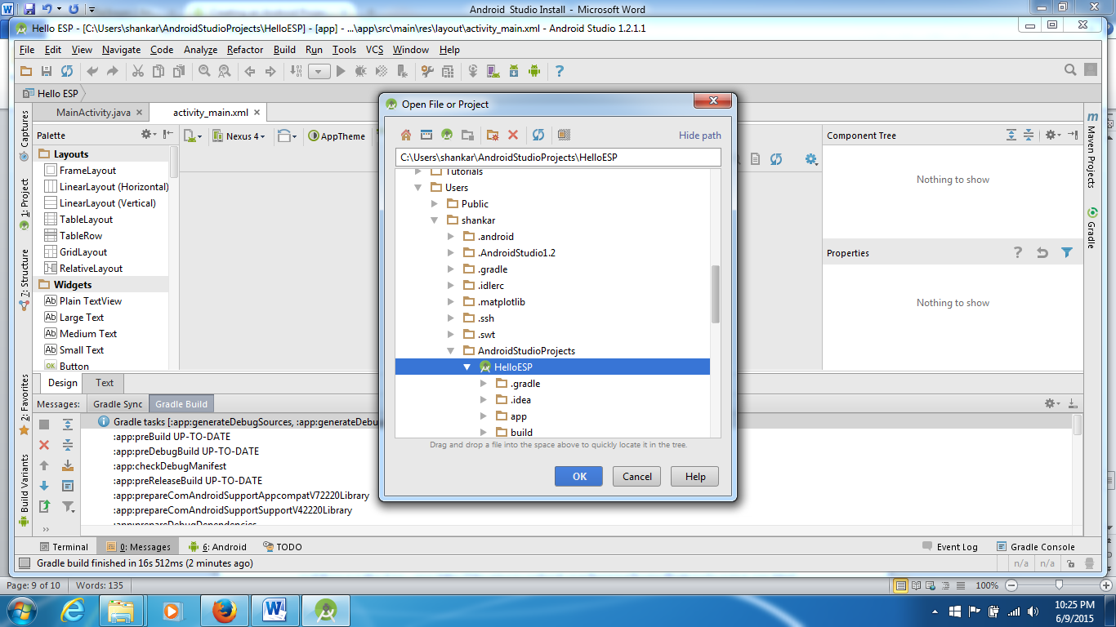

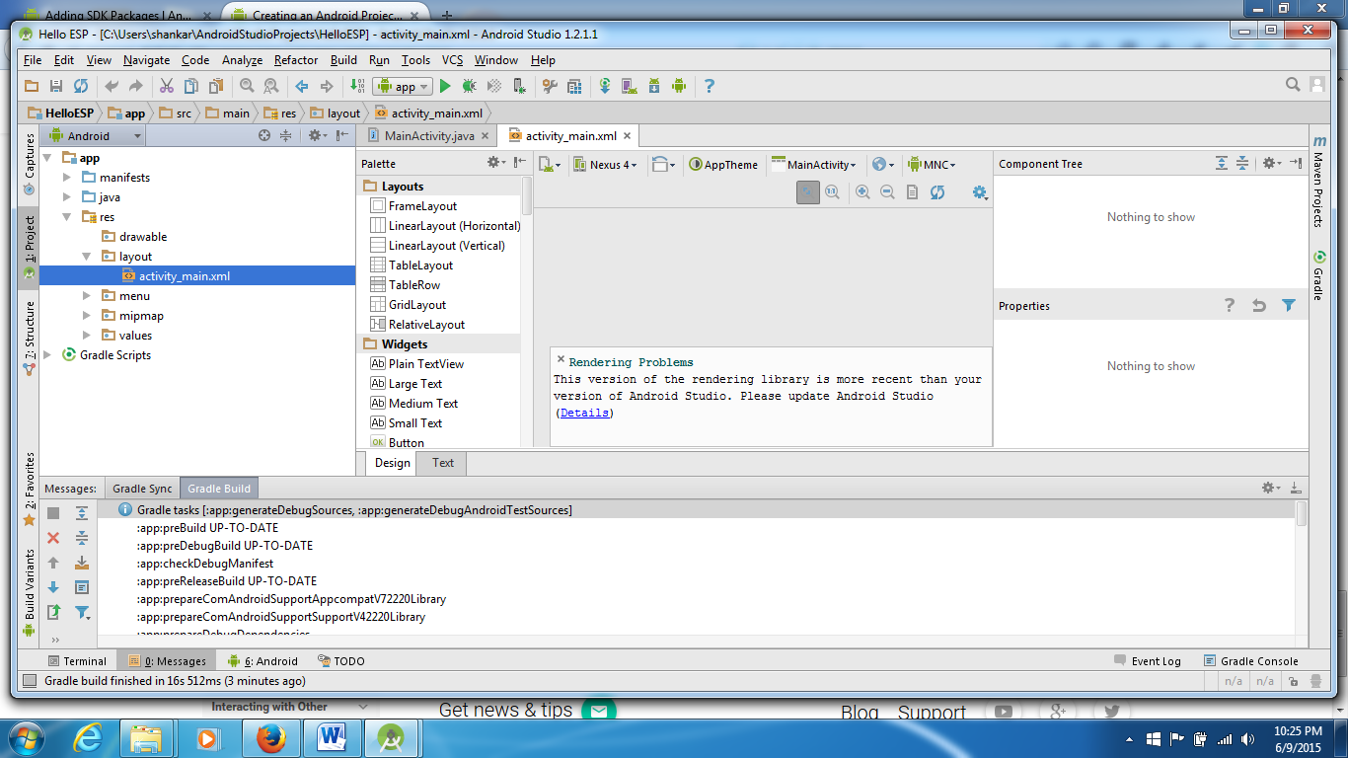

Explore the file structure:

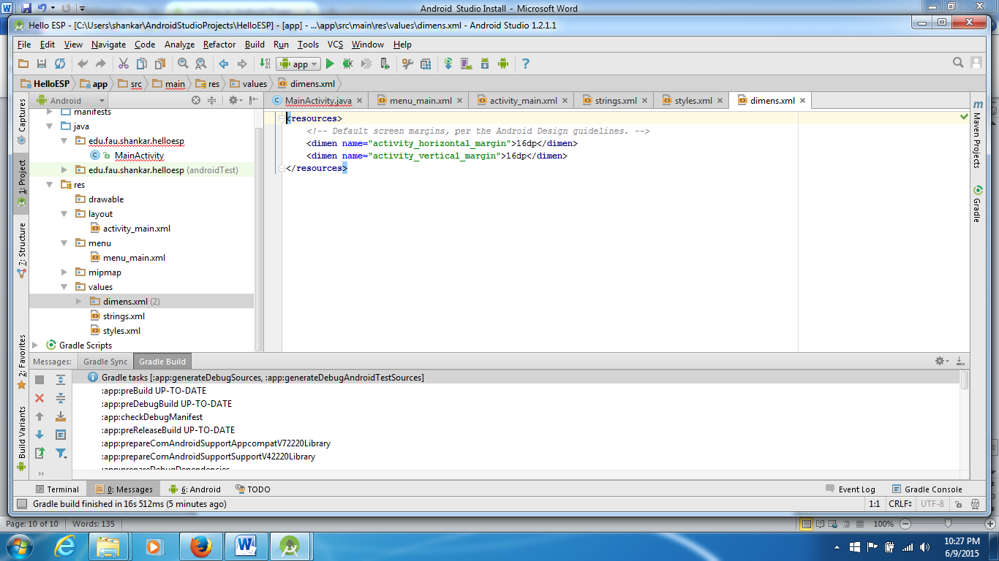

Create AVD:

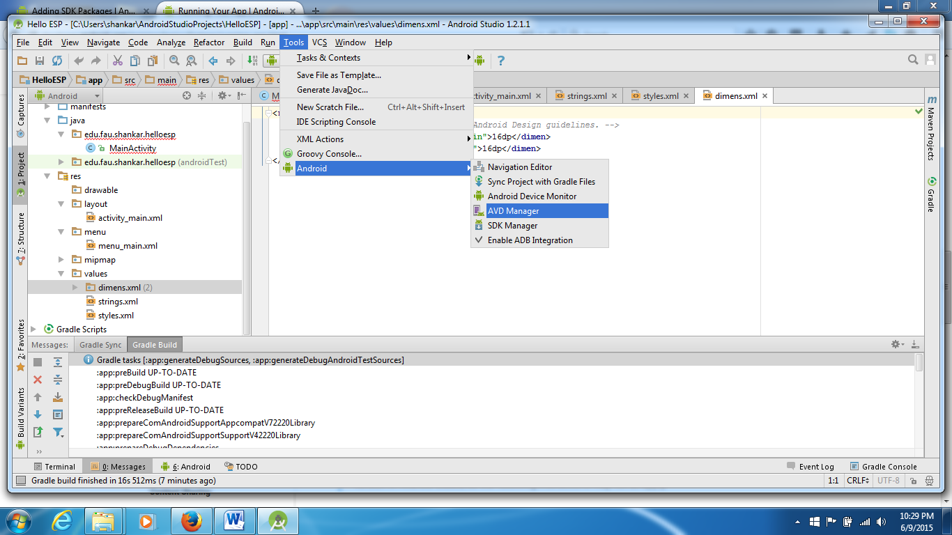

Choose Nexus 7 Tablet:

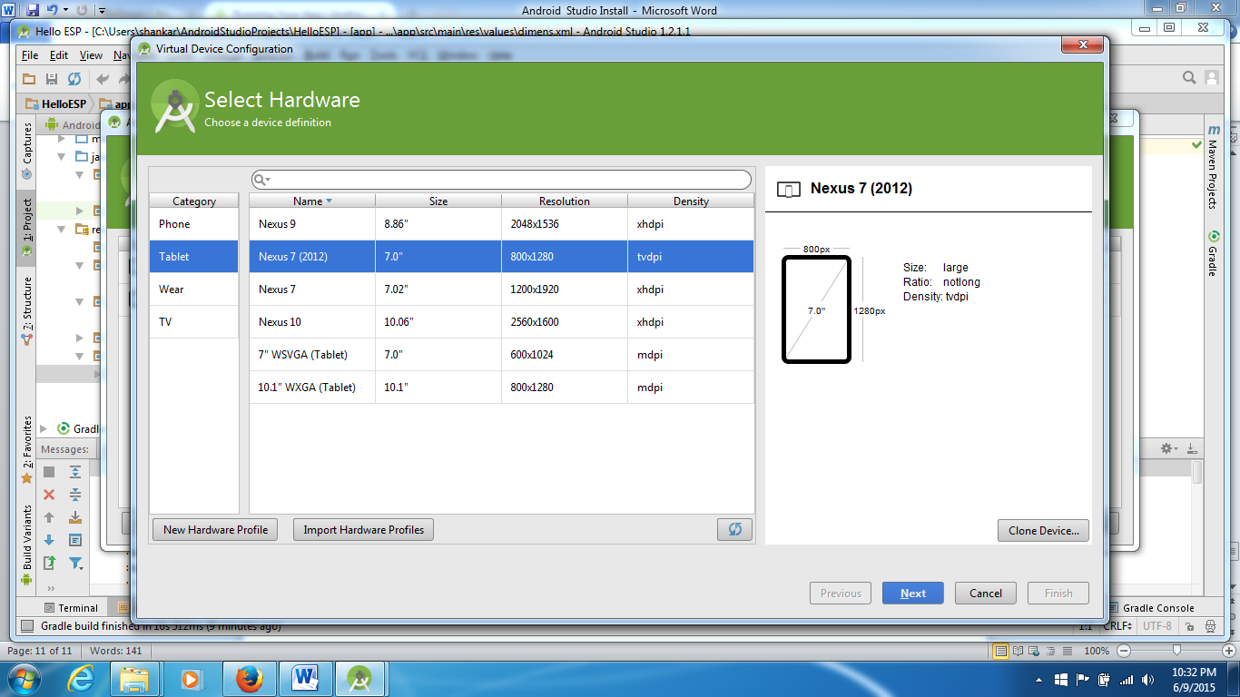

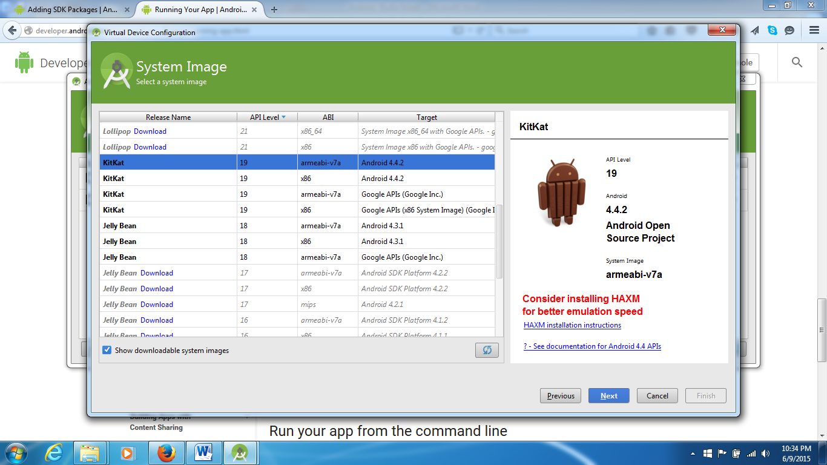

and then run the App – see: <http://developer.android.com/training/basics/firstapp/running-app.html>

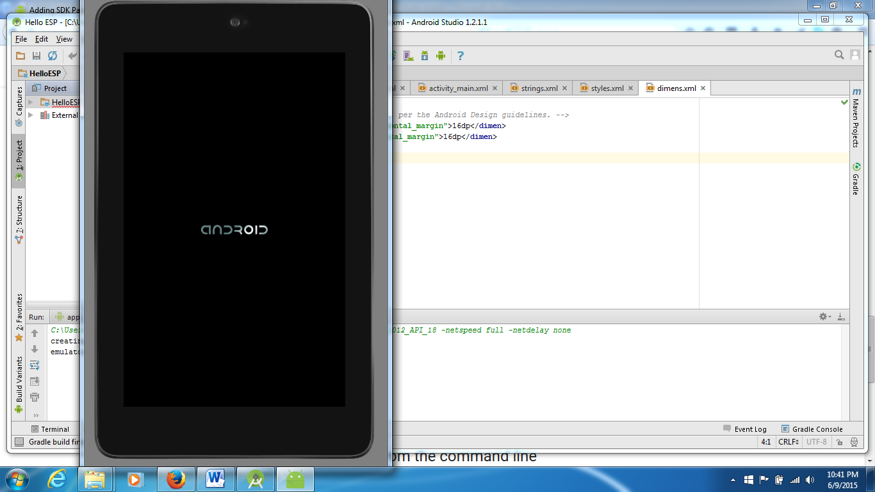

Result:

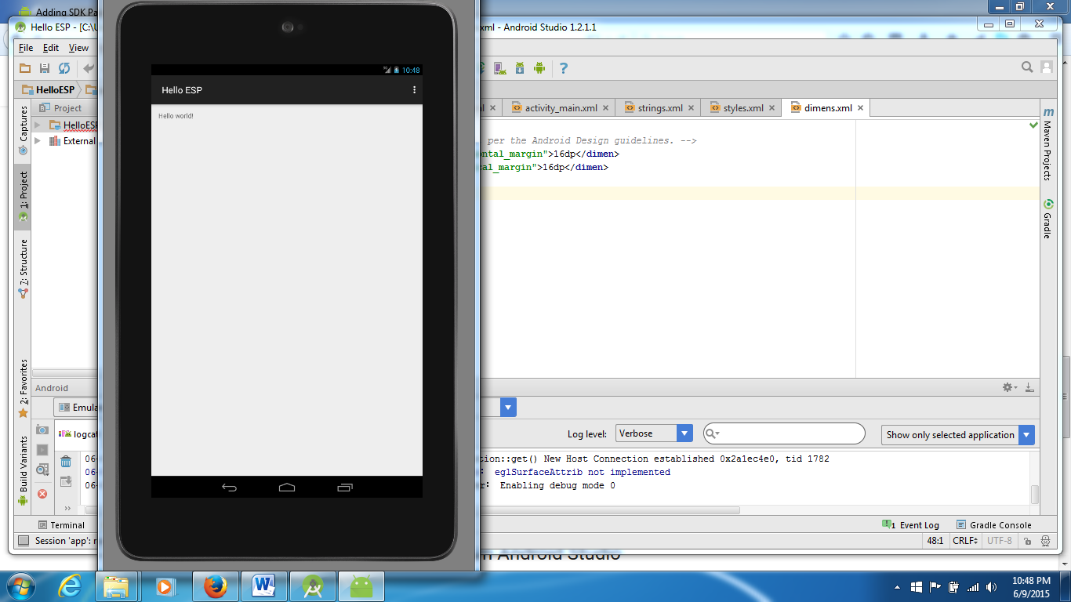

Run the App on the device:

Connect tablet and do the settings as given here: <http://developer.android.com/training/basics/firstapp/running-app.html>

as seen here:

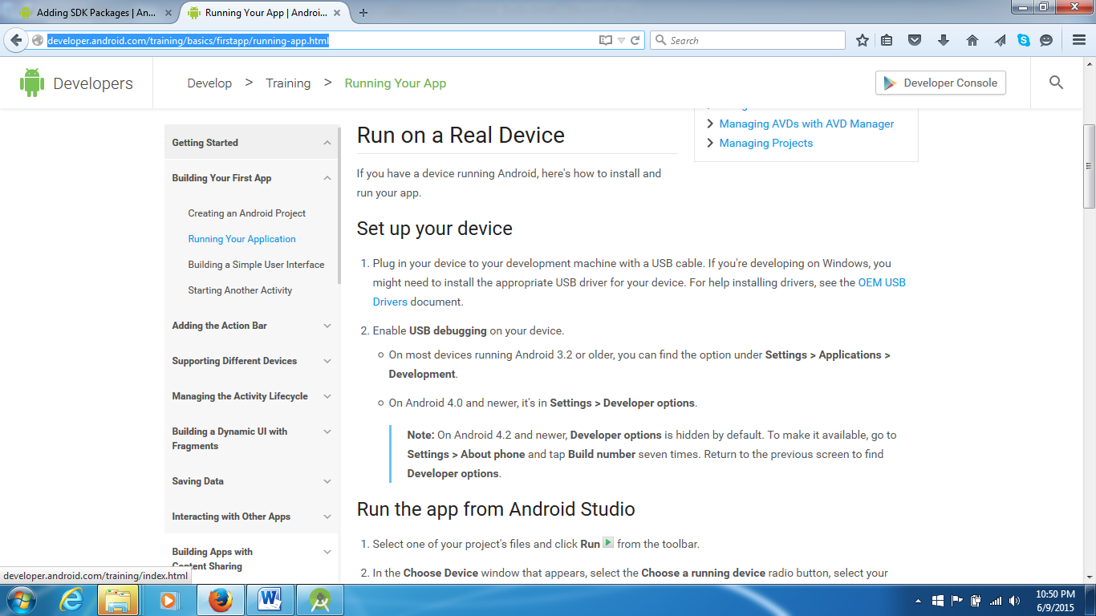

Run 🡪 Choose a running device as follows:

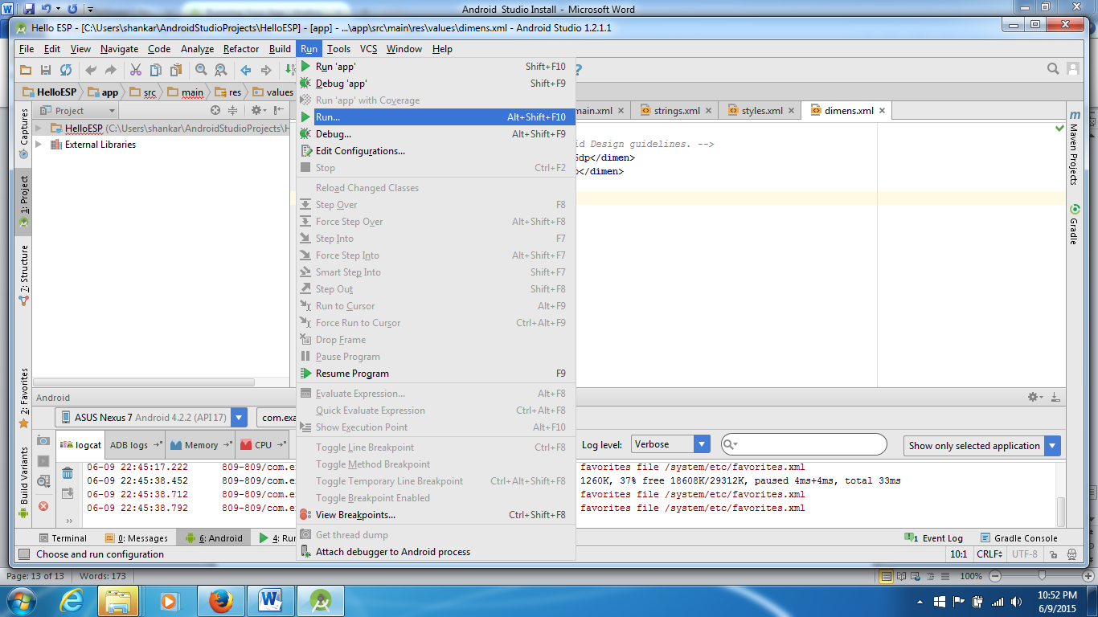

Turn on your phone and say OK for debug mode.

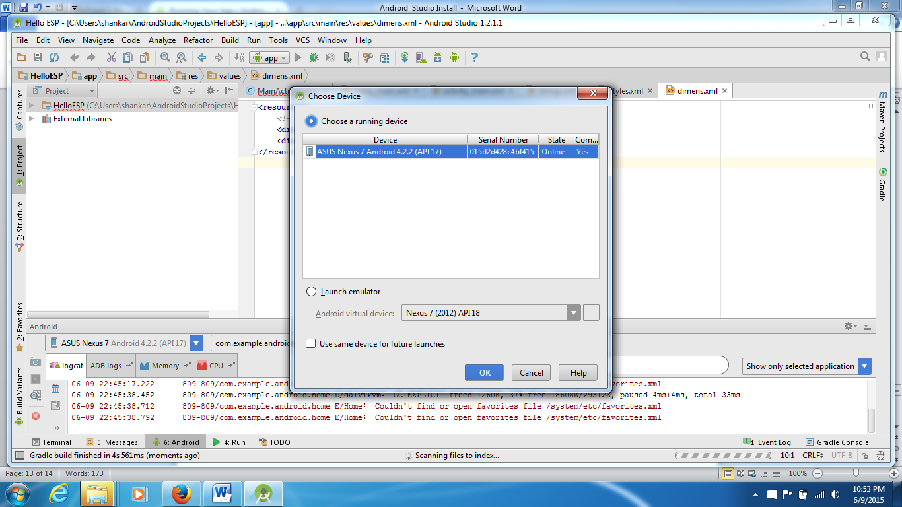

Verified that it launches on the tablet. There is a way to do a screen capture the tablet screen also. More on that later!